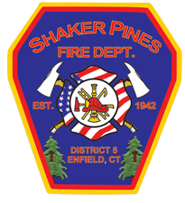
Shaker Pines Fire Department
Cadet Program

Thank you for your interest in becoming a Cadet Firefighter with the Shaker Pines Fire Department.
Attached are the Program Application, Parent Consent Form and School Principal Consent Form. Please have them completed and submit them back to the department for review.
Below is an excerpt about the Application Process from the Cadet Roles & Responsibilities:
Membership applications shall proceed through a two-part process: 1) The Application (documentation) phase, and 2) The Interview phase.
Membership applications for the Cadet Program must be submitted to the Cadet Program Officer.
The following MUST be submitted to the Cadet Program Officer as a complete application package:
- Completed and signed membership application
- Completed and signed Parent/Guardian Consent Form
- Original or certified proof of age or birth certificate (for copy)
- Report card (most recent, for copy)
- Completed and Signed School Principal Consent Form
- Social Security card (for copy)
After receipt of ALL documentation, the application will be reviewed by the Cadet Program Officer and two Cadet Program Advisors. If all documentation is received and all qualifications for membership eligibility are met the application shall be deemed complete, and the Interview Phase will be scheduled.
If you have any questions, feel free to contact the Cadet Program Officer, Captain Amanda Mele at AMele@SPFD.net or the Chief of the Department, James Nolan at JNolan@SPFD.net, or (860) 749-8552.

