President: Peter G. Burk
Vice President: Guy Beck
Clerk: Margaret Guyette
Commissioners: Scott Beiler
Peter Burk
Treasurer: Scott Wyllie
SHAKER PINES FIRE DISTRICT #5
A regular meeting of the Shaker Pines Fire District was held on Tuesday, May 6, 2025 at the fire station.
Those present were President Peter G. Burk, Vice President Guy Beck, Clerk Margaret Guyette, Commissioner Peter Burk, Commissioner Scott Beiler, Treasurer Scott Wyllie, Fire Chief James Nolan, Deputy Fire Chief Edward Prajzner, and Administrative Assistant Jolene Bauckman.
President Burk called the meeting to order at 7:00 PM.
MINUTES: The minutes for April 2025 were presented to the Board members. A motion to accept the minutes was made by Vice President Beck and Commissioner Beiler made a second to the motion. A vote was taken, it was unanimous, and the motion carried.
TREASURER’S REPORT: Treasurer Wyllie submitted the treasurer’s report for April 2025 to the Board members. A motion to accept the treasurer's report was made by Vice President Beck and Commissioner Burk made a second to the motion. A vote was taken, it was unanimous, and the motion carried.
CORRESPONDENCE: We received the renewal survey from Emergency Services Insurance Program (ESIP)/McNeil & Company for property insurance.
FIRE CHIEF REPORT: Fire Chief Nolan submitted his report verbally. Town-wide training continues and has been very beneficial to all of the departments. Calls in all of the districts have shown the benefits of the training.
Connecticut Fire Academy delivered an SCBA trailer that was used for training last week.
A water softener system that was previously approved has been successfully installed.
The department’s UTV has been very beneficial in recent weeks. It was used in brush fires in Hampden, MA as well as Ellington, CT. The UTV was also put to use in the Berlin (Hawthorne) fire in the fall. We received reimbursement from the state in the amount of $4,589.
The ESIP/McNeil renewal documents were received. The renewal quote was $5,654 less than the amount on the approved budget. Chief Nolan recommended increasing the agreed value of the engines to $1 million each, which will increase the renewal by $1,084 and will still be below the budgeted amount.
FIRE MARSHALL REPORT: Deputy Chief Prajzner read the report and it was placed on file. We had 75 incidents, 1 plan/site review at 215 Moody Road, and 5 inspections. The monthly fire drill at LEGO Creative Child Care was conducted. There was no training to report in April 2025.
REPORTS OF COMMITTEES: Vice President Beck and Deputy Chief Prajzner gave an update from the consolidation committee. A meeting was held May 1, 2025 during which all commissioners from the four consolidating districts voted unanimously to accept the resolutions to begin the consolidation process. The resolutions were signed by the commissioners. The committee now has 18 months to complete the referendum to be presented to the town’s taxpayers in November 2026. Eastern Connecticut University has a program in their master level classes that may work for our supervisory uses. The consolidation committee will meet with them at the next meeting on May 22, 2025.
OLD BUSINESS: There was no old business to discuss.
NEW BUSINESS: There was no new business to discuss.
BILLS: The Board members reviewed the bills. A motion to pay the bills as submitted was made by Vice President Beck and Commissioner Burk made a second to the motion. A vote was taken, it was unanimous, and the motion carried.
ADJOURNMENT: A motion to adjourn the meeting was made by Vice President Beck and Commissioner Burk made a second to the motion. A vote was taken, it was unanimous, and the motion carried. The meeting adjourned at 7:43 PM.

Respectfully submitted,
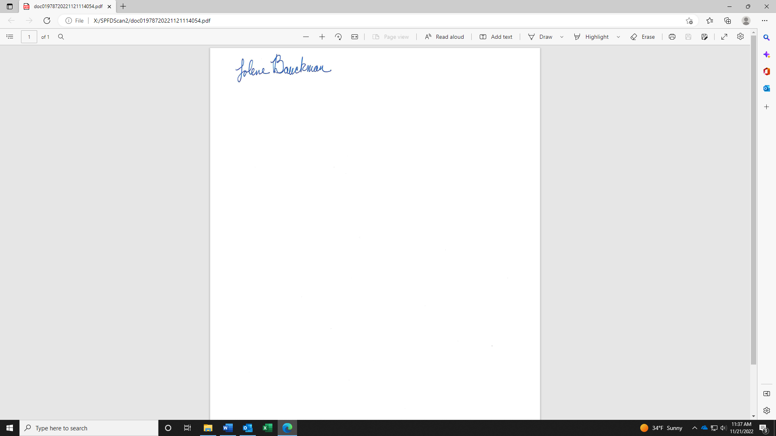
Jolene Bauckman
Administrative Assistant

