President: Peter G. Burk
Vice President: Guy Beck
Clerk: Margaret Guyette
Commissioners: Scott Beiler
Peter Burk
Treasurer: Scott Wyllie
SHAKER PINES FIRE DISTRICT #5
A regular meeting of the Shaker Pines Fire District was held on Tuesday, August 12, 2025 at the fire station.
Those present were President Peter G. Burk, Clerk Margaret Guyette, Commissioner Peter Burk, Commissioner Scott Beiler, Treasurer Scott Wyllie, Fire Chief James Nolan, Deputy Fire Chief Edward Prajzner, and Administrative Assistant Jolene Bauckman.
President Burk called the meeting to order at 7:00 PM.
MINUTES: The minutes for July 2025 were presented to the Board members. A motion to accept the minutes was made by Commissioner Burk and Commissioner Beiler made a second to the motion. A vote was taken, it was unanimous, and the motion carried.
TREASURER’S REPORT: Treasurer Wyllie submitted the treasurer’s report for July 2025 to the Board members. A motion to accept the treasurer's report was made by President Burk and Commissioner Burk made a second to the motion. A vote was taken, it was unanimous, and the motion carried.
CORRESPONDENCE: We received notes of thanks from a fire department in Maine and from several residents.
FIRE CHIEF REPORT: Fire Chief Nolan submitted his report verbally. Members from Shaker Pines and North Thompsonville fire departments participated in the extrication demonstration as a part of the Enfield Fourth of July Celebration. We also participated in the Enfield Police Department’s National Night Out event.
Firefighter Armstrong is currently on medical leave, and Lieutenant McGuire will be on medical leave in September. Both are planned and not the result of any duty injury.
We received $94,602.14 from the State of CT for a motor vehicle tax grant.
We are in the process of transitioning our national reporting process from National Fire Incident Reporting System (NFIRS) to National Emergency Response Information System (NERIS). Chief Nolan reports that the system appears to be more detailed while also being easy to use. We look forward to completing the transition to NERIS by the start of 2026.
FIRE MARSHALL REPORT: Deputy Chief Prajzner read the report and it was placed on file. We had 85 incidents, no plan/site reviews, and 7 inspections. The monthly fire drill at LEGO Creative Child Care was conducted. No training was completed.
REPORTS OF COMMITTEES: Deputy Chief Prajzner gave an update from the consolidation committee. The committee has not met recently due to members being unable to attend. One ongoing item is the use of a student from Eastern CT State University to act as a spokesperson to disseminate information to the public. The group may also consider hiring a public relations firm for that role. There are several sub-committees made up of firefighters, full time staff, part time and volunteer members, etc. who have been making very good progress in their respective groups. The referendum will most likely not come to a vote in November 2025 because the committee feels it is more important to solidify plans and make meaningful progress so that the voters will have a clear picture of what they are voting on. Additionally, they plan to create a report that will outline what each of the 4 consolidating departments will look like within the next 5 years if consolidation happens and if it does not.
OLD BUSINESS: Commissioner Beiler asked for an update on the live fire training facility that will be built on the Shaker Pines property that will potentially be utilized by all of our mutual aid partners. Chief Nolan responded that the town-wide training committee is diligently working on a proposal that will be presented soon. They are also researching whether National Fire Protection Association (NFPA) statutes exempt the project from certain municipal requirements.
NEW BUSINESS: There was no new business to discuss.
BILLS: The Board members reviewed the bills. A motion to pay the bills as submitted was made by Commissioner Beiler and Commissioner Burk made a second to the motion. A vote was taken, it was unanimous, and the motion carried.
ADJOURNMENT: A motion to adjourn the meeting was made by Commissioner Beiler and Commissioner Guyette made a second to the motion. A vote was taken, it was unanimous, and the motion carried. The meeting adjourned at 7:55 PM.

Respectfully submitted,
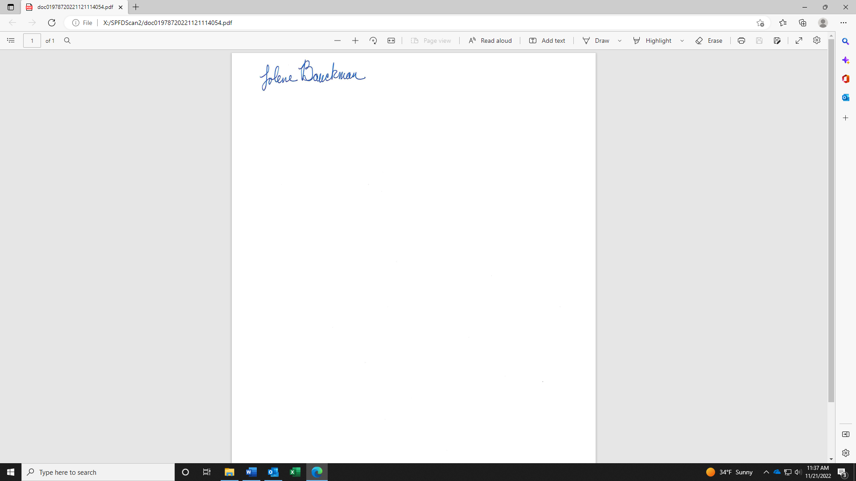
Jolene Bauckman
Administrative Assistant

